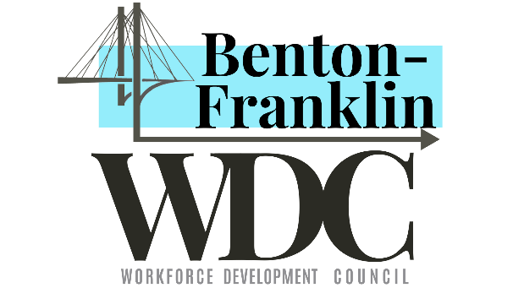
Benton-Franklin Workforce Development Council
Workforce Innovation and Opportunity Act (WIOA)

Subject: Branding and Social Media Policy
Policy No: 2015-30
Effective Date: 05/19/2017, 06/9/2017, 1/2/2019, 4/5/2019, 7/16/2019, 9/5/2019, 2/20/2020, 6/19/20, 9/22/20, 12/29/2020

Purpose:
To promote the services and events offered at or hosted by WorkSource Columbia Basin (WSCB) (ie. programs, job-fairs, hiring events, workshops, job clubs, etc.) on social media platforms and all communication materials.

Policy:
This policy establishes Benton-Franklin Workforce Development Council’s (BFWDC) position and approval process regarding the WorkSource Columbia Basin Social Media Accounts and other communication materials to ensure quality, accountability, and a cohesive marketing image in all communication materials produced by WSCB Staff.

A. Social Media is for Business Purposes Only
- Representing WSCB in any social media capacity must be approved by BFWDC.
Note
If a post has already been uploaded on a WorkSource Columbia Basin social media platform, an individual may share on their page without further authorization.

- If staff uses a work email address to create an account, it is no longer a personal account. It will be considered a work-owned account and it must comply with branding standards.

B. Process and Procedures for Branding Requirements

- All communication from partners and/or employers that promote the services and events offered at or hosted by WSCB (i.e. programs, job-fairs, hiring events, workshops, job clubs, etc.) must be reviewed by a WSCB Branding Coordinator and then approved by the Benton-Franklin Workforce Development Council (BFWDC) Brand and Media Designee prior to distribution, including Facebook and YouTube posts as outlined in Attachment A - Flyer/Material Development and Approval Procedure for WorkSource Columbia Basin)

- Social Media use is subject to federal and state laws, policies and guidelines, including but not limited to “Guidelines and Best Practices for Social Media Use in Washington state,” (see attached Attachment B – Quality Standards for Social Media)

Note
If a post has already been uploaded on a WorkSource Columbia Basin social media platform, an individual may share on their page without further authorization.

- A WSCB YouTube account to be used to help with service delivery is allowed. It is to be created and overseen by the WorkSource Operations Manager. Comments will be disabled to prevent the need to monitor the account and the risk of customer comments being missed. Contact information for the job center or WSCB Staff shall be included to allow customers to reach the center with inquiries.

C. Definitions

Communication Materials- refers to literature, newsletters, publications, signage, websites, advertisements, brochures, video, radio and public service announcements, press releases, press events advisories and all other related materials.

Social media- refers to any interactive Web-based technologies used for social networking and for sharing, discussing and/or developing content. Types of social media include, but are not limited to, blogs, video or photo-sharing sites, and social networking sites. Examples of social-media sites include, but are not limited to, YouTube, Twitter, Facebook, Snapchat, LinkedIn and Instagram.

Social networking- refers to the use of social media for building online communities and/or communicating with groups of individuals.

ATTACHMENT A

Flyer/Material Development and
Approval Procedure for WorkSource Columbia Basin

Background
The WorkSource brand is a shared asset among all partners comprising the system. A single brand identity (WorkSource) requires diligence and commitment to maintain quality standards and prosper as a first-choice identity. Branding standards have been established to guide the look, feel and quality of WorkSource-related communication products. To represent WorkSource Columbia Basin (WSCB) in a consistent and professional way, all communication from partners and/or employers that promote the services and events offered at or hosted by WSCB (i.e. programs, job-fairs, hiring events, workshops, job clubs, etc.) must be approved by the Benton-Franklin Workforce Development Council (BFWDC) Brand and Media Designee prior to distribution including Facebook posts.

Branded flyers must include the following:
- Current WorkSource logo;
- WorkSource color scheme;
- Approved typography;
- Copyright free images;
- Clear concise message; and
- Current Equal Opportunity Statement.

Branding Coordinators
There are 5 Branding Coordinators at WSCB who will initially assist you in creating your WorkSource flyer. They are your first point of contact in the development of flyers, and will provide guidance on branding standards, as well as review the spelling and grammar of the final document. The Branding Coordinators are listed as follows:
Arturo Espinoza (aespinoza@esd.wa.gov)
Jasmine Sanchez (jsanchez@esd.wa.gov
Jessica Ramirez (jramirez@esd.wa.gov
Jose Delgado (jdelgado@esd.wa.gov
Marla Skoglund (mskoglund@esd.wa.gov)

Brand and Media Designee
Once a flyer has been produced, it must be approved by the BFWDC Brand and Media Designee, Becky Smith (bsmith@bf-wdc.org). If the Brand and Media Designee is not available, the backup to the Brand and Media Designee is David Chavey-Reynaud, (dchavey@bf-wdc.org). The Branding Coordinator will send the completed flyer electronically to the Brand and Media Designee for review and approval. If a flyer is needed, and the Branding Coordinator that typically assists you with a flyer is out of the office, please reach out to another Branding Coordinator for assistance.

Creating New Flyers
- Create a flyer using the flyer templates or complete the Flyer Request Checklist (WorkSource Flyer Request Form) and submit to your WorkSource Branding Coordinator a minimum of 5 days before your desired distribution date.
- The Branding Coordinator will send the completed flyer electronically to the Brand and Media Designee (bsmith@bf-wdc.org) for approval.
- Once the Brand and Media Designee has approved the flyer, it will be sent back to the coordinator for distribution with a cc to the Operations Manager, Crystal Bright (cbright@esd.wa.gov), and GRS Supervisor, Ric Valdez (rvaldez@esd.wa.gov)

Previously Approved Flyers
- Please resubmit all previously approved flyers to a Branding Coordinator for a quick review before sending them out for distribution. This includes updates of the date, time, and/or contact information.
- Materials containing our former WSCB logo, outdated Equal Opportunity (EO) tagline, and non-compliant branding color schemes shall be updated to meet branding standards.

WorkSource Logo
The WorkSource logo should appear with only the American Job Center network tagline below the WorkSource word mark in all promotional products and publications. Local identifiers should not appear under the logo.

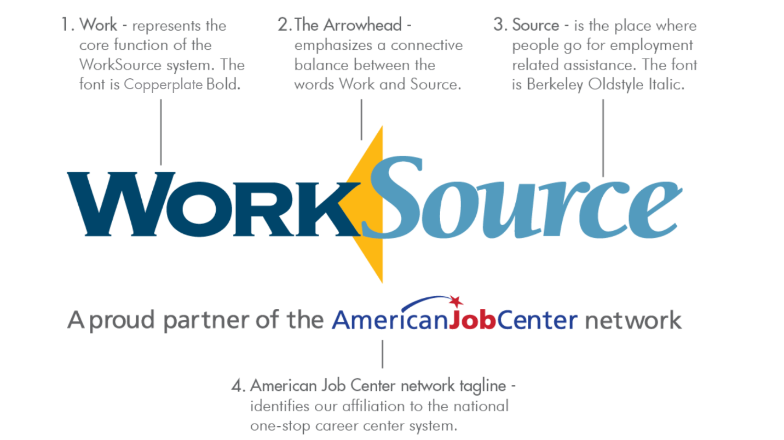

The logo consists of three elements: the word Work, the arrowhead, and the word Source. Each of the individual elements maintains a special relationship to the others and must not be altered except by overall enlargement or reduction.

Additionally, every state is required to show affiliation to the national one-stop career center system. Washington has elected to meet this requirement by placing the approved tagline “A proud partner of the American Job Center network” underneath the WorkSource logo. It must be used as shown regardless of personal preference.

Download logos
Download a complete set of WorkSource logos.

DOWNLOAD INDIVIDUAL LOGOS
Simply select the appropriate link from the list below.
Note
When downloading a PNG or JPG, the image will open in a separate browser window.
Right click the image and select "save image" to download it to your hard drive.
When you select any of the EPS file links, the logo will automatically save to your "downloads" file.
(EPS files are vector and therefore not viewable in browser windows)
CMYK
For use in digital and offset printing when four color process is used.
- WorkSource_ajc_cmyk.jpg
- WorkSource_ajc_cmyk.eps

RGB
RGB files for use in Web pages, PowerPoint presentations or any publication that will be viewed on a monitor or screen. They may also be used in publications printed on an office desk jet or laser printer.
- WorkSource_ajc_rgb.jpg
- WorkSource_ajc_rgb.png

GRAYSCALE
These images are best when printing on a digital device or offset printer when black is the only ink color available, but the device can print grays and halftones accurately.
- WorkSource_ajc_gray.jpg
- WorkSource_ajc_gray.eps

BLACK
These files are to be provided when black is the only available option. (A receipt from an ATM for example or a fax).
- WorkSource_ajc_black.jpg
- WorkSource_ajc_black.png
- WorkSource_ajc_black.eps

REVERSE/WHITE
For overlay on any dark background.
- WorkSource_ajc_reverse.png
- WorkSource_ajc_reverse.eps

REVERSE WITH COLOR
For overlay on any dark background.
- WorkSource_ajc_reverse&yellow.png
- WorkSource_ajc_reverseyellow.eps
- WorkSource_ajc_reverse,yellowblue.png
- WorkSource_ajc_reverse,yellow&blue.eps

WorkSource Color Scheme
Below are the Primary, Secondary and American Job Center (AJC) tagline color schemes. Use only primary and secondary colors when creating WorkSource materials. Use CMYK values for printed documents. Use RGB and HEX values for digital media. Provide the Pantone™ number for vinyl and embroidery color match.

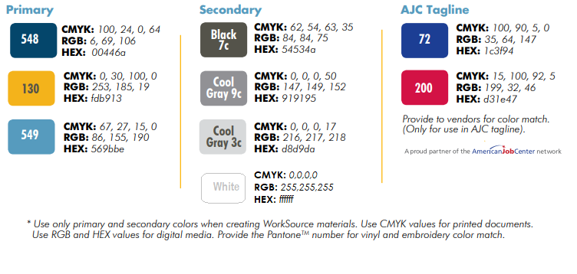

Approved Fonts
The approved fonts for WSCB are:
- Futura
- Century Gothic (substitute for when Futura is not available)
- Arial (e-mail or material creation)
- Calibri (e-mail only)
These fonts can be used through regular, bold, light, condensed and italic faces.

Copyright Free Images
When creating flyers, ensure that when the picture is maximized to 100% view, the photo remains clear. Ensure that we are utilizing photos that are high-resolution, rights-free photos – See WorkSource Washington Brand Standards found on www.worksourcebrandbasecamp.wa.gov.

Clear and Concise Message
Ensure that there is one clear, concise goal or purpose. Take note of white space, and don’t bury what’s important with too much of any element. This includes words, graphics, even space. A few should be held in prominence while others should be relegated into a supporting role. For Hiring Events include:
- Date and time of the Hiring event - when referring to the time convention, please ensure that the ante meridiem and post meridiem have the periods in place. Example: “a.m.” vs “am”;
- Location of where the event will take place;
- Keep the information short, concise and attention grabbing;
- Reference finding us on Facebook at WorkSource Columbia Basin and encourage users to find us on WorkSourceWA.com using the Job ID when applicable;
- Consistency – Ensure that proper grammar and spelling is throughout the messaging. (ex. if a series in a bullet starts with a capital letter, ensure the entire series shares that same flow)

E-mail
Due to standard business practices, the approved fonts for emails within WSCB are Arial and Calibri. These fonts can be used through regular, bold, light, condensed and italic faces. The minimum font size shall be size ‘8,’ with recommended font size as 10. Emails must be in blue or black font.

Black RGB – 0,0,0
Blue RGB – 68,114,196

E-mail Signatures
As we want to ensure that all materials that come through WSCB is branded appropriately, one avenue that is considered branding is e-mail. Signature information must match the text on your WorkSource business card. This communicates a consistent identity and serves the interest of the entire WorkSource system. Additionally, we wanted to make hyperlinks and feedback easy to capture so you’ll see this embedded down below. Listed below, you will find the components of a branded signature, in the order and format required. Additional components are not allowable.

- Name;
- Position;
- Address;
- Phone number(s): if you have multiple phone numbers it is acceptable to list them all;
- E-mail address;
- Satisfaction survey invitation and hyperlink;
- WorkSourceWA hyperlink;
- EO Tagline;
- Optional – ‘Like us on Facebook’ linking to WorkSource Columbia Basin’s Facebook page;
- If applicable – for bilingual individuals, place “I speak xx,” in the corresponding language.
(Examples: “Se Habla español,” or “я говорю на русском.”);
- Optional – utilize the hyperlink ‘Say yes to those who served;’
- If applicable – for those that want to include their Workforce Development certificates they can use a small logo no larger than 1 inch or just list the certifications they received.
(Examples include, but are not limited to: Luma certified, CWDP certified, CBEP certified, Lean Six Sigma certified);
- Optional – utilize the hyperlink ‘Like our Veterans Employment Page on Facebook.’

Sample Email Signature 1
Jane Employee
Local Veterans Employment Representative
WorkSource Columbia Basin
815 N Kellogg St, Suite D
Kennewick, WA 99336
P. (509)734-1234
E. email@esd.wa.gov
Se Habla español
Say yes to those who served
Certified: CBEP, CWDP, Luma, Six Sigma Green Belt

Tell Us How We Did!
WorkSourceWA.com
Like us on Facebook - WorkSource Columbia Basin
Like our Veterans Employment Page on Facebook

WorkSource is an equal opportunity employer/program. Auxiliary aids and services are available upon request to individuals with disabilities. WA Relay Service: 711

Sample Email Signature 2
Jane Employee, CBEP, CWDP
Local Veterans Employment Representative
WorkSource Columbia Basin
815 N Kellogg St, Suite D
Kennewick, WA 99336
P. (509)734-1234
E. email@esd.wa.gov
Se Habla español

Tell Us How We Did!
WorkSourceWA.com
Say yes to those who served
Like us on Facebook - WorkSource Columbia Basin
Like our Veterans Employment Page on Facebook

WorkSource is an equal opportunity employer/program. Auxiliary aids and services are available upon request to individuals with disabilities. WA Relay Service: 711
Social Media
When this is anticipated to be posted on Social Media, ensure that we are utilizing the Social Media template found in the preferred platform Canva or you can download them here if another platform is being used:

Vertical Yellow
Vertical Light Blue
Vertical Light Gray
Vertical Dark Gray
Vertical Dark Blue
Horizontal Yellow
Horizontal Light Blue
Horizontal Light Gray
Horizontal Dark Gray
Horizontal Dark Blue
Note
A flyer can be created and disseminated without having the Social Media template, however if the intent is to also have it shared on Social Media, the template must be used.

Equal Opportunity (EO)
The approved EO statement is required for all WorkSource products, publications and promotions. *
- English:
  - WorkSource is an equal opportunity employer/program. Auxiliary aids and services are available upon request to individuals with disabilities. WA Relay Service: 711
- Spanish:
  - WorkSource es un empleador/ programa con oportunidades equitativas. Previa solicitud equipos auxiliaries y servicíos están disponibles para los individuos con discapacidades. Servicio de Retransmisión WA: 711

Important:
For EO taglines, if a person will be able to see both sides of the flyer (i.e. have it picked up, have it mailed, received electronically, etc.) it is fine to have it on one side. However, if it is posted somewhere where only one side is available to view (i.e. a bulletin board, in a frame, etc.) the tagline should be on the side that is visible.

* If services are discussed or promoted on products, you shall ensure the EO tagline is located at the bottom. Additionally, if a phone number is listed on the document, you shall include WA Relay Service: 711 in the tagline.

Platforms
The preferred platform for creating flyers is Canva, however Publisher, PowerPoint, and Word may be utilized. If there are other platforms that would like to be considered, please refer to a Branding Coordinator or Supervisor to escalate to the Brand and Media Designee.

ATTACHMENT B

Quality Standards for
Social Media
Supporting Washington WorkSource Brand Standards for quality and unified communications statewide.

Social Media Business Pages or Groups must be approved by the Washington WorkSource Association’s (WWA) Brand & Media Group via a standardized form posted on the InsideESD site. See Brand and Media Designee for details.
Role Definitions
- Brand and Media Designee: appointed by the Benton-Franklin Workforce Development Council to manage the shared WorkSource brand asset in their WDA and statewide, are members of Washington Workforce Association’s (WWA) WorkSource Brand & Media Group, responsible for the consistent integrity of the brand and all its expressions.
- Content Publishers: individuals in addition to the Brand and Media Designee having administrative access and permissions to post to social-media sites.
- Information Stakeholders: staff and partners within the WorkSource system who provide information that can result in posted content.

Brand Expression
- Profile and cover/banner image templates must be used for standardized brand expression across all WorkSource social media pages and platforms, and for all accounts—to further professional, consistent and branded representation.
- Post templates should be used whenever appropriate to give a consistent, professional, branded look to WorkSource social-media pages. The templates are available on the WorkSource Brand Basecamp.Social media posts that do not fit one of the templates need to be approved by the Brand and Media Designee.
Quick Tip! The majority of templates were developed in PowerPoint. To use the slide as an image on a post, save it as a .JPG image (a feature of PowerPoint). Use the jpeg to enhance brief text describing the event featured in the image.
- Any assets (for example: icons, illustrations, photographs, images) must meet specifications in accordance with WorkSource Washington Brand Standards. You can find these standards at: www.worksourcebrandbasecamp.wa.gov
- Posts that are not WorkSource branded (for example: content that is not a WorkSource event, announcement, story or otherwise) should utilize the alternative template, in order to maintain the uniform, professional presentation of posts.
Administrative Oversight
- Social media accounts are overseen by the Benton-Franklin Workforce Development Council Brand and Media Designee.
  - Oversight competencies include:
- Brand management skills, including standardization and quality expression.
- Social media platform knowledge, including how each platform is uniquely leveraged for business use – If Brand and Media Designee does not have social media for business knowledge, they are responsible for training themselves and/or receiving support as such.
  - Oversight responsibilities include:
- Content management flexibility and quality, including spelling, punctuation and grammar consistency – See below for additional information related to social media tone and voice.
- Maintaining administrative permissions on each account.
- Monitoring communications and responses, proofing posts as needed—particularly in content publisher onboarding stage(s).
- Determining content publishers, providing onboarding and training prior to granting administrative permissions – Publishers’ competencies include professional-level written communication skills, consistency in writing and formatting, valuing social media as a business tool, openness to training as needed for social media business use.
- Training, onboarding and providing brand support to content publishers including ongoing direction and guidance as needed. - For account consistency, have content publishers work with ESD social-media lead-, when work accounts are needed for platform access.
- Ensuring one or more representative from each WDA attends Social Media Team meetings.
- Ensuring information stakeholders are briefed on protocols and content contribution processes.

Content Standards
See above for “Brand Expression” and official WorkSource Washington Brand Standards (www.worksourcebrandbasecamp.wa.gov) for all asset and expression standards.
- Tone, Voice
  - To ensure the widest access to messaging, use simple words, avoid jargon or slang and resist using sarcasm or puns that won’t translate to other dialects and/or demographics.
  - Use active voice (vivid verbs).
  - Avoid all acronyms.
  - Pertinent / relevant content, especially in response to conflict questions or concerns, should be tied to the provision of seamless and quality employment and training services to job seekers and businesses.
- Assets
  - High resolution, rights-free photos – See WorkSource Washington Brand Standards for direction related to images and photography. (www.worksourcebrandbasecamp.wa.gov)
  - No clip art
- Content Type (may include:)
  - WorkSource sponsored events,
  - Third party/partner events and resources (please use the branded templates for these posts, as well as events located at WorkSource sites),
  - Tips and resources for the job search,
  - Training opportunities,
  - Hot jobs,
  - Performance results,
  - Labor-market highlights, and
  - Quotes / Testimonials

Quick Tip! For Content Posting: 80-20 rule of content management is recommended: 80% of content adds value to the customer’s life and addresses their need, 20% is celebratory and/or for brand awareness
Quick Tip! For Content Organization: A recommended practice is to create a local folder in which to catalog/record all posts and online conversations. This is for back-up and possible disclosure purposes.
Conversation Management

Quick Tip! In the unfortunate event of abusive or crude language, posts or behavior requiring that a user be blocked, screenshot or copy the content and paste into a dedicated Word document. Save the document to a dedicated area accessible by all content publishers to your social media page(s).
- General Conversation Management
  - Consistency - Each Brand and Media Designee determines that area’s social media processes for posting and roles of content publishers.
  - Tone
    - Set and keep a positive, professional, welcoming and value-add tone.
    - Represent the mission and vision of WorkSource with a clear, professional and gracious tone.
  - Timeliness
    - Provide responses within 24 hours in a business week as a best practice for all questions and comments.
  - Privacy & Professionalism
    - Take conversations to email or Facebook Messenger, as appropriate (For example, “For your security and privacy, please message this page.” Or “We are happy to continue the conversation in answer to your questions via ____@____.”)
- Responding to Negative Comments, Posts, Reviews
  - Negative posts and bad reviews should not be deleted (unless qualifying as such, per the standardized comment policy), but used as opportunities to engage customers and show goodwill.
- Hiding Comments or Replies
  - Comments or posts that are outright against policy can be hidden on Facebook (Please note: they will not be hidden to the poster or their friends), though continued abuse can and should result in banning/blocking from the site per the comment policy.
  - Comments or posts that are about personal, individual issues or questions should be hidden and the conversation taken to the private side.
Legal Considerations
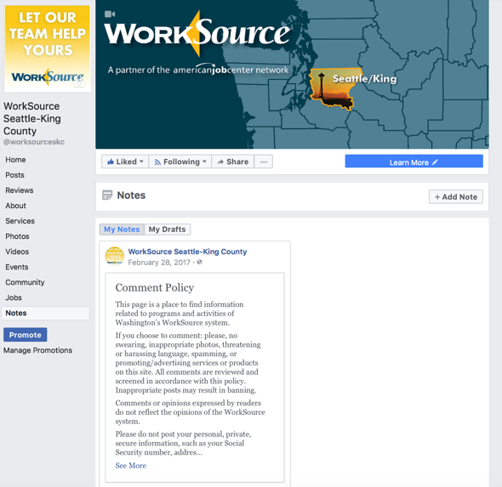
- Comment Policy
  - Any time comments are hidden or deleted, or someone is banned from a site, a record must be made of the comment and reason for hiding/deleting. This is for public disclosure reasons and for record of action.
  - Policy must be included in “Notes” section of page (as pictured, example right)
This page is a place to find information related to programs and activities of Washington’s WorkSource system.
If you choose to comment: please, no swearing, inappropriate photos, threatening or harassing language, spamming, or promoting/advertising services or products on this site. All comments are reviewed and screened in accordance with this policy. Inappropriate posts may result in banning.
Comments or opinions expressed by readers do not reflect the opinions of the WorkSource system.
Please do not post your personal, private, secure information, such as your Social Security number, address or phone number. Because of confidentiality requirements, we will not use this site to discuss any specific unemployment-benefits claims – past, present or future. We also will not disclose private information that we are legally required to keep confidential.
If you have questions about your unemployment-benefits claim, you can look up your information on our website https://secure.esd.wa.gov/home/ or call the Claims Center at 800-318-6022.
Equal Opportunity information
WorkSource is an equal opportunity employer/program. Auxiliary aids and services are available upon request to individuals with disabilities.
Relay information
Washington Relay Service: 711
- Confidentiality
  - Social media posts are both public in the direct sense of the word—viewable publically, as well as public record. Staff are required to maintain customer confidentiality and must not disclose or request personal information in public areas of social media sites. Reminder: offer communication follow-up via the private messaging feature of the business page or staff email address(es) as needed.
- Equal Opportunity
  - Please use the official WorkSource Equal Opportunity (EO) tagline – See Brand and Media Designee or WorkSource Brand Basecamp for the most up-to-date language.
  - WorkSource is restricted from showing support for political or socio-political stances such as: union / non-union, religion, political affiliations, ballot measures, political candidates, etc.
- Assets & Photography
  - In accordance with WorkSource Washington Brand Standards, any third party images, illustrations or assets must be rights-free and/or cited with source credit and/or with signed and recorded image release – See Brand and Media Designee or WorkSource Brand Basecamp for image release forms.
Resources & Tools
These resources and industry publications may be useful for social media management.
- Links:
  - 64 Facebook Content Tips
  - ‘What Should I Post on Facebook?’ 12 Facebook Tactics Working Right Now
  - 7 Popular Goal-Setting Strategies That Will Help You Achieve Great Things on Social Media
  - Social Media Tip Sheet #4: Measuring Success
  - A beginner's guide to social media
  - Twitter: The Basics
  - 10 Hashtag Best Practices You Should Start Using Today
  - 8 Ways for Government to Engage Citizens with Social Media
  - Facebook’s Top 10 for Government
  - 8 Ways Non-Profit Organizations Can Maximize their Facebook Page
  - Social Media and Public Agencies: Legal Issues You Should Know About
  - Facebook Ad Specs and Image Sizes [Fully Updated for 2018]
  - “Inbound vs. Outbound” marketing (descriptions here and here).
- Industry e-Newsletters:
  - SocialFresh
  - Who's Blogging What
  - Hubspot (e-newsletter + blog subscribe)
  - Buffer Social
  - Mashable

